The Tori'i Pitch for GSND 5110 GP3

Nian'yi Wang

# Introduction

This is a first-person runner game, sort of like *Subway Surfer* but it's different.

The player is walking down a road, trying to get to the other end. While walking, the player quickly noticed something is wrong—the road is never ending, and the atmosphere feels spooky. As the player finally decides to look around to figure out what's wrong, a horrifying thing shows up in the direction the player came from. It is approaching the player closer and closer, and they have to run, even though it's an endless road.

While running, obstacles would appear on the way in various ways, such as the roots of the road-side trees, rocks or even ghosts. Running into them would cause the player to be knocked back a bit, shortening the distance between them to the thing behind. The player must make sure to not get captured by the thing.

A short period later, a rifle gun appears on the road [don't ask why it's there, just take it]. The player takes it and finds out that it could be used to damage the thing; but when they turn around to shoot, their pace would slow down, so they have to balance between running and shooting. Also, the ammo of the gun is not infinite; the player needs to pick up the ammos appearing on the way to refill the gun.

Finally, the thing is defeated, and the player reaches the other end of the road.

# Visual Style

We combine a Japanese [Tori'i](https://en.wikipedia.org/wiki/Torii) (鳥居, *"bird-living"*), a wild forest path and a spooky night to get the desired atmosphere (Figure 1), as a Tori'i is symbolically considered as the pathway linking the human's world and the God's world.

|  |
| --- |
| Torii | Gate, Japan, Shrines, Meaning, & Facts | BritannicaHiking Japan's Ancient Roads | All ...61 SPOOKY NIGHT ideas in 2024 | spooky, dark art, beautiful moon |

Figure 1 The elements used to composite the desired style.

The combined result looks like Figure 2: The player is walking alone in a wild Tori'i path on a spooky night.

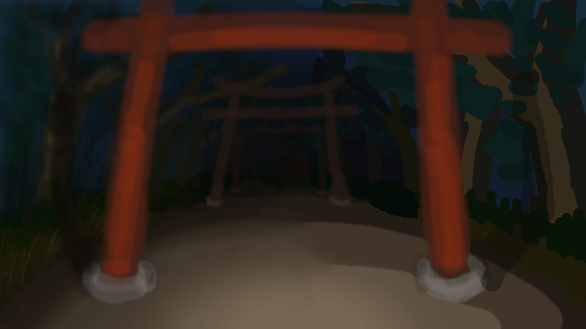

Figure 2 An illustration of the player's in-game perspective.

# Walkthrough

1. Start of the game.
   1. Instructions of movement and camera control are displayed in the lower area of the screen. The player automatically moves forward until active input is received.
   2. The player normal walks along the road, feels nothing wrong.
   3. The player finally feels wrong and starts suspecting. They might look around and try to walk in the opposite direction.
   4. The horrific thing won't appear immediately, but until the second time the player turns around. After it appears, a flashing warning text saying "RUN!" would appear for a few seconds.
2. Main game (early half).
   1. The player runs along the road to prevent getting caught by the thing. While they're running, a UI indicating the distance to the thing is shown constantly in the middle of the screen. The player could also hear the heartbeat: The closer the thing is, the faster the heart beats.
   2. Various obstacles will appear on the way. If they failed to dodge an obstacle, they'll be knocked back closer to the thing.
   3. If they stopped running, the thing would approach closer.
   4. If the thing ever approached the player, they'll be caught and dead.
3. Main game (later half).
   1. A rifle gun appears on the way and the player (inevitably) fetches it, with a pack of ammo loaded. Then an HP bar appears on the screen, leading the player to shoot the thing.
   2. The player could turn back to shoot the thing, but doing so would make it impossible to run forward; so they have to alternate between shooting and running.
   3. When the ammo runs out, the player must collect ammo that appeared on the way to refill the gun.
4. End of the game.
   1. After the player finally defeats the thing, they could then walk forward to the end of the road.
   2. As they reaches the end, the scoring screen appears and the game ends.